Lone Star Orienteering Club Event
Saturday, 9 January 2027
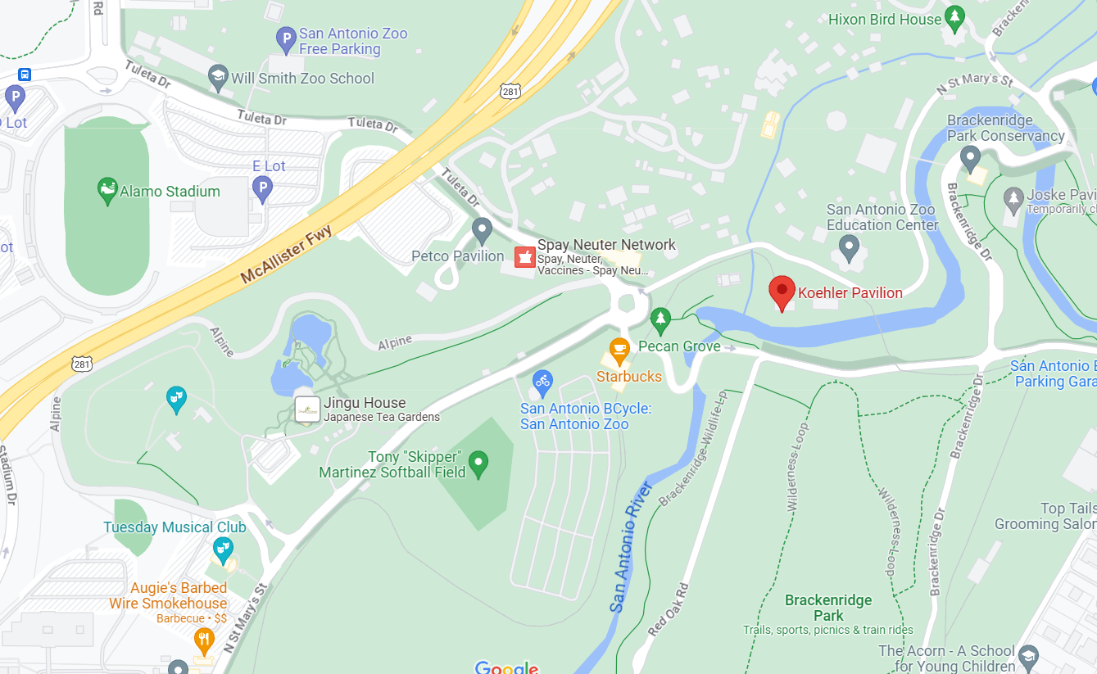
Join LSOC at Brackenridge Park on Saturday, 9 January 2027 for a Sport Orienteering event. Several parking areas are available (see map below).

Meet site is east of train station
Alternate Parking Entrances

Parking Entrance for shortest walk to meet site

Directions
South on US 281, exit Hildebrand Avenue, turn right on Hildebrand Avenue, go .3 miles and turn left Devine Road, Go .1 miles and turn left on Tuleta Drive, go .4 miles and at the traffic circle take the 1st exit onto N Saint Mary’s Street, go 479 feet and turn left into the parking lot. Park and walk to the east of the train station.
North on US 281, exit Stadium Drive toward Saint Mary’s Street and go .3 miles, turn right on Saint Mary’s Street and go .6 miles, turn right into the Brackenridge Train parking lot. Park and walk to the east of the train station.
Same-day registration is not allowed. Registration ends 6 January 2027. Payments will be accepted on-site if pre-coordinated.
All courses require an E-Punch finger stick. E- Punch finger sticks are available for rental ($3). Participants must bring their own compass.

Courses (estimated controls and distances)
Course | Description | Controls | Distance
White | Beginner Novice course | 10 | 2.3 km
Yellow | Novice course | 14 | 2.9 km
Orange | Intermediate course | 14 | 4 km
Green | Advanced course | 14 | 4.3 km

Classes
White | Yellow | Orange | Green
F 13- | F13- | F1-18 | F1-18
F-14-18 | F14-18 | M1-18 | M1-18
F-Open | M13- | F-Open | F18+
M13- | M14-18 | M-Open | M18+
M-14-18 | F-Open |  | M35+
M-Open | M-Open |  | F35+
 |  |  | M50+
 |  |  | F50+

Fees
Fees are shown below. One map per registration fee. This race is for individual starts. The control points must be visited in the specified order shown on the map.

Registration
Age | Entry Cost
18 and younger | $20.00
19 and over | $30.00
Map Walk | $15

Schedule
Participants will request their start time when completing registration online. Participants start times will be posted on the LSOC website prior to the event. All participants are encouraged to begin the course promptly at their start time. A 15-20 minute beginner class is offered at 0920 at the start area. The first start is at 10:00 am, the last start is at 12:00 noon, with a 2-hour time limit for all courses. LSOC prefers to start runners as early as possible so we can have maximum attendance at the earliest possible time for the awards ceremony. All runners must be off all courses by 2:00 pm. The awards ceremony will be held no later than 2:pm at the start/finish area. The award ceremony usually starts at 1230 pm.

Meet Director
Clai Gardner 210-315-4057
lonestarorienteer@gmail.com

