San Antonio Orienteering Event
Saturday, 7 November 2026
Join LSOC at Olmos Basin Park on Saturday, 7 November 2026 for a Sport Orienteering event. We will be at the Olmos Basin Clubhouse area West of the Alamo Heights HS baseball field. Several parking areas are available (see map below).
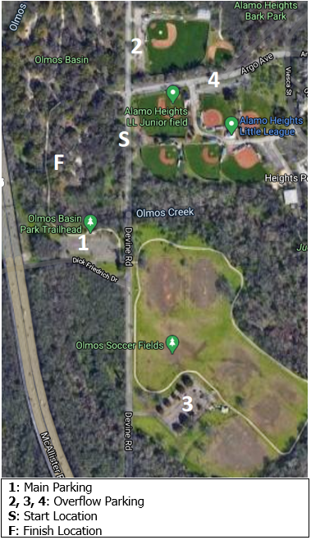
Traffic circle parking
Parking Entrance closest to start
Same-day registration is not allowed. Registration for pre-payment online ends 4 November. No documentation or payments will be accepted on-site unless pre-coordinated.
All courses require an E-Punch finger stick. E- Punch finger sticks are available for rental ($3). Participants must bring their own compass.

Courses (estimated controls and distances)
Course | Description | Controls | Distance
White | Beginner Novice course | 10 | 2.3 km
Yellow | Novice course | 14 | 2.9 km
Orange | Intermediate course | 14 | 4 km
Green | Advanced course | 14 | 4.3 km

Classes
White | Yellow | Orange | Green
F 13- | F13- | F1-18 | F1-18
F-14-18 | F14-18 | M1-18 | M1-18
F-Open | M13- | F-Open | F18+
M13- | M14-18 | M-Open | M18+
M-14-18 | F-Open |  | M35+
M-Open | M-Open |  | F35+
 |  |  | M50+
 |  |  | F50+

Fees
Fees are shown below. One map per registration fee. This race is for individual starts. The control points must be visited in the specified order shown on the map.

Registration
Age | Entry Cost
18 and younger | $20.00
19 and over | $30.00

Schedule
Participants will request their start time when completing registration online. Participants’ start times will be posted on the LSOC website prior to the event. All participants are expected to begin the course promptly at their start time. A 15-20 minute beginner class is offered at 0920 at the Olmos Clubhouse area. The first start is at 10:00 am, the last start is at 12:00 noon, with a 2-hour time limit for all courses. LSOC prefers to start runners as early as possible so we can have maximum attendance at the awards ceremony. All runners must be off all courses by 2:00 pm. The awards ceremony will be held no later than 2:pm near the Olmos Clubhouse area. The award ceremony usually starts around 1230 pm.

Meet Director
Clai Gardner 210-315-4057
lonestarorienteer@gmail.com

