**San Antonio Orienteering Event  
Saturday, 29 March 2025**

Join LSOC at Highlands High School in San Antonio, Texas on Saturday, 29 March 2025 for a Sport Orienteering event. After parking in the designated lot, please follow the signs to the registration/Start area. Parking area identified on the map below.

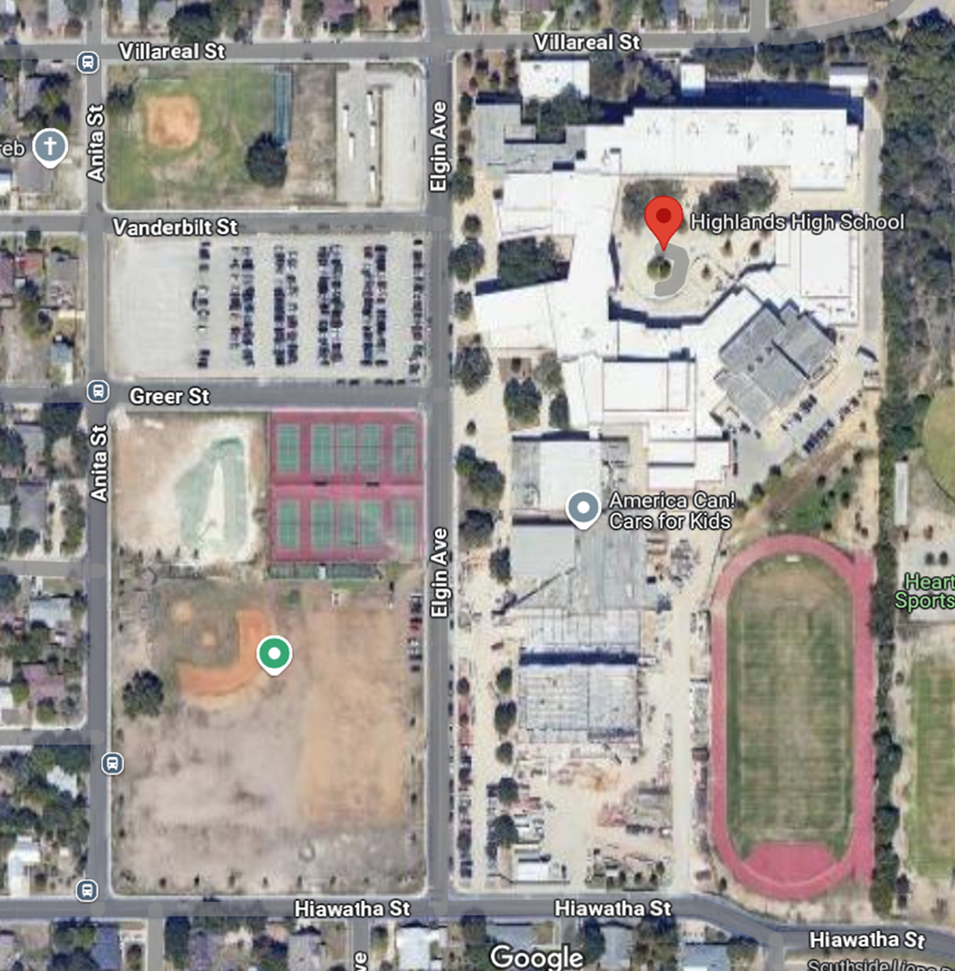

**Parking Entrance**

**Parking**

**Same-day registration is not allowed**. Registration for pre-payment online ends 25 March. **No documentation or payments will be accepted on-site unless pre-coordinated**. Group registration is available using the form found online.

All courses require an E-Punch finger stick. E- Punch finger sticks are available for rental ($3). Participants must bring their own compass.

**Courses (estimated controls and distances)**

|  |  |  |  |
| --- | --- | --- | --- |
| **Course** | **Description** | **Controls** | **Distance** |
| White | Beginner Novice course | 10 | 2.3 km |
| Yellow | Novice course | 14 | 2.9 km |
| Orange | Intermediate course | 14 | 4 km |
| Green | Advanced course | 14 | 4.3 km |

**Classes**

|  |  |  |  |
| --- | --- | --- | --- |
| **White** | **Yellow** | **Orange** | **Green** |
| **F 13-** | **F13-** | **F1-18** | **F1-18** |
| **F-14-18** | **F14-18** | **M1-18** | **M1-18** |
| **F-Open** | **M13-** | **F-Open** | **F18+** |
| **M13-** | **M14-18** | **M-Open** | **M18+** |
| **M-14-18** | **F-Open** |  | **M35+** |
| **M-Open** | **M-Open** |  | **F35+** |
|  |  |  | **M50+** |
|  |  |  | **F50+** |

**Fees**

Fees are shown below. One map per registration fee. This race is for **individual starts**. The control points must be visited in the specified order shown on the map

.

|  |  |
| --- | --- |
| **Registration** | |
| **Age** | **Entry Cost** |
| **18 and younger** | **$20.00** |
| **19 and over** | **$30.00** |

**Schedule**

Participants will request their start time when completing registration online. Participants’ start times will be posted on the LSOC website prior to the event. All participants are expected to begin the course promptly at their start time. A 15-minute beginner class is offered at 0930 at the registration area on the Highlands High School campus. The first start is at 10:00 am, the last start is at 12:00 noon, with a 2-hour time limit for all courses. LSOC prefers to start runners as early as possible so we can have maximum attendance at the awards ceremony. All runners must be off all courses by 2:00 pm. The awards ceremony will be held no later than 2:pm on the Highlands High School campus. The award ceremony usually starts around 1 pm.

**T shirts**

T-shirts will be available for sale.

**Livelox**

Recommend you download the Livelox app for use during this event.

**Weather**

For current forecast click [here](https://www.wunderground.com/weather/us/tx/san-antonio).

**Meet Director**

Clai Gardner 210-315-4057

lonestarorienteer@gmail.com